Letters in Binary

In the table on the right, fill in the cells below the colored blocks. The first line
has been done as an example.

Match the 8 bits to the binary code
chart below to find out what letter it represents.

Bits n Bytes
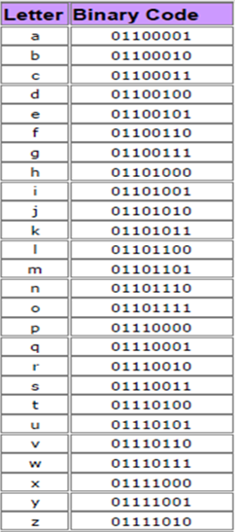

ON bits (write “1”) are white. OFF bits (write “0”) are black.
Code |  |  |  |  |  |  |  |  | Letter
128 | 64 | 32 | 16 | 8 | 4 | 2 | 1
 |  |  |  |  |  |  |  |  | d
0 | 1 | 1 | 0 | 0 | 1 | 0 | 0 |  | d
 |  |  |  |  |  |  |  |  | a
0 | 1 | 1 | 0 | 0 | 0 | 0 | 1 |  | a
 |  |  |  |  |  |  |  |  | v
0 | 1 | 1 | 1 | 0 | 1 | 1 | 0 |  | v
 |  |  |  |  |  |  |  |  | i
0 | 1 | 1 | 0 | 1 | 0 | 0 | 1 |  | i
 |  |  |  |  |  |  |  |  | s
0 | 1 | 1 | 1 | 0 | 0 | 1 | 1 |  | s
 |  |  |  |  |  |  |  |  | t
0 | 1 | 1 | 1 | 0 | 1 | 0 | 0 |  | t
 |  |  |  |  |  |  |  |  | e
0 | 1 | 1 | 0 | 0 | 1 | 0 | 1 |  | e
 |  |  |  |  |  |  |  |  | c
0 | 1 | 1 | 0 | 0 | 0 | 1 | 1 |  | c
 |  |  |  |  |  |  |  |  | h
0 | 1 | 1 | 0 | 1 | 0 | 0 | 0 |  | h

